Middleware Programming: Project Report

Volunteer Website

Priyam Rao

Prof. Nguyen Quach

2/7/2021

Introduction | 3
- Background to the problem | 3
- Problem Statement | 3
- Your approach to solve the problem | 3
Description of your work | 4
User manual | 6
conclusion | 7

- Introduction:
Background to the problem:
Since I am designing a website, the user will create their own accounts and while creating their accounts they will provide their credentials which they will use to log into their own accounts. Since they will be using the same credentials, we need to store them somewhere where we can find it and match it with the user entered credentials at the time of next login. If they both are matching, then the user is legitimate. Then we can allow him/her to access the account.

The problem statement:
we need a storage from which we can retract the user’s data whenever we want and when a new user wants to create his account and credentials, it is automatically stored in the storage. We need something like that.

Your approach to solving the problem:
The best possible solution for this problem is Database. The user’s credentials and all the data he uploaded, can be in the database. The database can store all the credentials and all the data the users have uploaded without getting it mixed up with other user’s data.
The database also provides security to the data. The user can only access his/her own account. They cannot enter into someone else’s account.

- Description of your work:
I have created three different tables in the MySQL database. I am going to put screenshots of the tables and also going to show the relational diagram of the database.

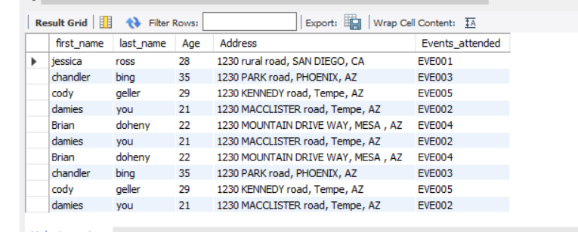
This is the first table. The table shows different information about the officers. Every officer has a unique ID, which is the OfficerID as we can see in the picture. Every officer is assigned to a certain event and overlooks volunteers.
The second table is Volunteers table.
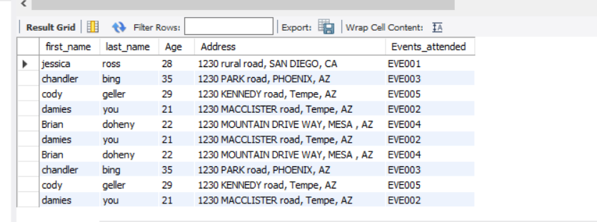
This table store information about the Volunteers. As we can see in the picture. Their names, age, addresses and events they attended are displayed In the table.
The third table is Events_organized table. That table displays the information about the events like event date or its venue number of people attended the event etc.
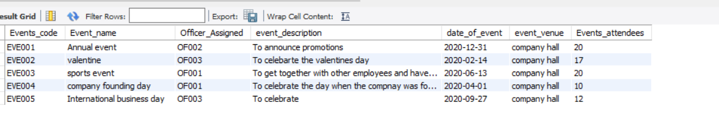

The relational diagram shows the relation of the tables.
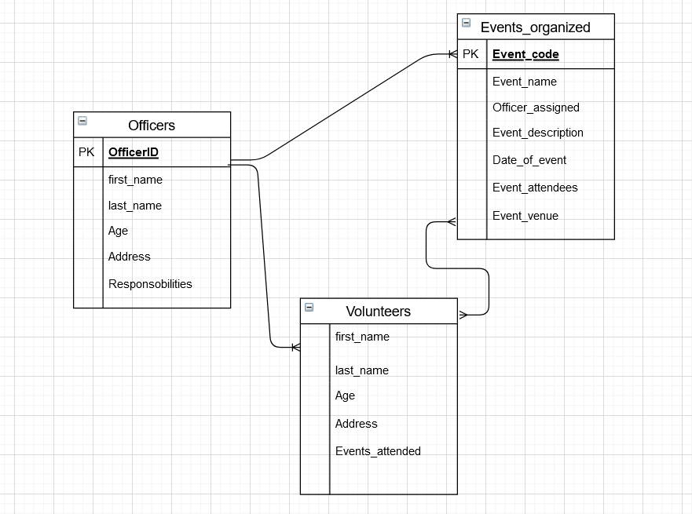

The diagram shows 3 different tables Officers, Volunteers and Events_organized. As we can see in the diagram that OfficerID and Event_code are primary keys for the tables Officers and Events_organized. The volunteers are not given any specific unique codes. One officer can be in-charge of many different events over the years but every event falls under any one officer only. Many volunteers can be participating in many different events. So, the relationship there would be many to many. And one officer can supervise many volunteers. So, there the relationship would be many to many.

- User manual:
- There are three files in the zip file Officer_Table, Volunteers_Table and Events_organized.
- Anyone who does not have any experience of the field can also run this SQL scripts.
- They should start with the Officers_Table. First they need to open it in the MySQL.
- Then they should run the database statements first. After that create table and at last insert statement.
- After they run the insert statement successfully, they can use theselect statement to see the output.
- They need to follow the same steps for both of the other files. They don’t need to create the database again and again they just need to write the use statement and they can get started.

- Conclusion:
What achieved: While designing the database, I managed to create three different tables, which represent three different entities involved in the company. These three tables be the foundation of the other functionality the database can provide.
What was learned: I have worked with database before and designed an entire database with all the functionalities. So, nothing was new. But there is one difference. I designed the database with SSMS. Now, I am working with the MySQL database. This is my first time with MySQL, I think this tool is awesome and very easy to use even for the first timers.
Challenges: I did not encounter any challenges. Only that it was first time using the MySQL. Other than that.
How can the work improve: Well the database is still in the developing phase. There can be stored procedures, CTEs and triggers.

